**AIM:** Model a simple HTML file describing your hometown (demonstrate the use of different tags)

**PROGRAM CODE:**

<html>

<head><title>Home Town</title>

</head>

<body bgcolor="pink">

<h1><center>CALICUT BEACH</center></h1>

<img src="image2.jpg" height="400px" width="700px">

<p><i>Kozhikode Beach or Calicut Beach is a beach on the western side of Kozhikode,

situated on the Malabar Coast of India. The beach is accessible through four road

overbridges in the city. The beach has paved stones and illumination. There is one Lions

Park for the children and an aquarium.</i></p>

</body>

</html>

**OUTPUT**

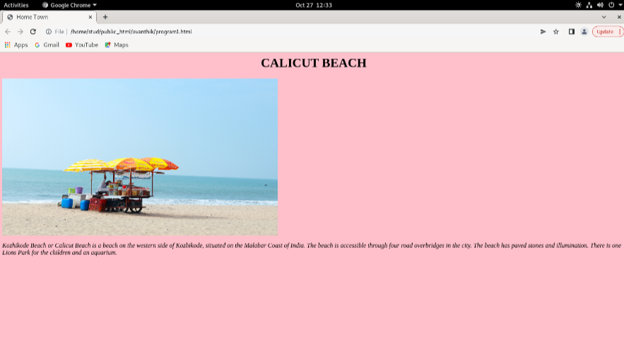

**AIM:** Create a webpage for displaying your biodata which contains images, tables, and also link within a page.

**PROGRAM CODE:**

ACADAMIC DETAILS

ACADAMIC DETAILS

<html>

<head><title>acadamic details</title></head>

<body bgcolor="yellow">

<h1><center>ACADAMIC DETAILS</center></h1>

<h3><u>BACHELOR OF COMPUTER APPLICATION</u></h3>

<table style="width:50%"border=3>

<tr>

<th>semester</th>

<th>Grade</th>

<th>cgpa</th>

</tr>

<tr>

<td>1</td>

<td>B+</td>

<td>7.5</td>

</tr>

<tr>

<td>2</td>

<td>A</td>

<td>8</td>

</tr>

<tr>

<td>3</td>

<td>B+</td>

<td>6.7</td>

</tr>

<tr>

<td>4</td>

<td>B</td>

<td>6.4</td>

</tr>

<tr>

<td>5</td>

<td>A</td>

<td>8</td>

</tr>

<tr>

<td>6</td>

<td>B</td>

<td>6.5</td>

</tr>

</table>

</body>

</html>

**Home page**

<html>

<head>

<title>BIODATA</title>

</head>

<body bgcolor="pink">

<h1><center><i>BIO DATA</i></center></h1>

<img src="a.jpg" align="right" height=110 width=100 1px>

<h3>NAME: AVANTHIK M</h3>

<a href="personaldata.html">PERSONAL DETAILS</a><br>

<a href="acadamicdetails.html">ACADAMIC DETAILS</a>

</body>

**PERSONAL DATA**

<html><head><title>personal data</title></head>

<body bgcolor="yellow">

<h1><center>PERSONAL DATA</center></h1>

<h3>Name : AVANTHIK M</h3>

<h3>Adress : Kozhikkod kerala india</h3>

<h3>Pin : 63306</h3>

<h3>Phone : 00000000000</h3>

</body>

</html>

**OUTPUT**

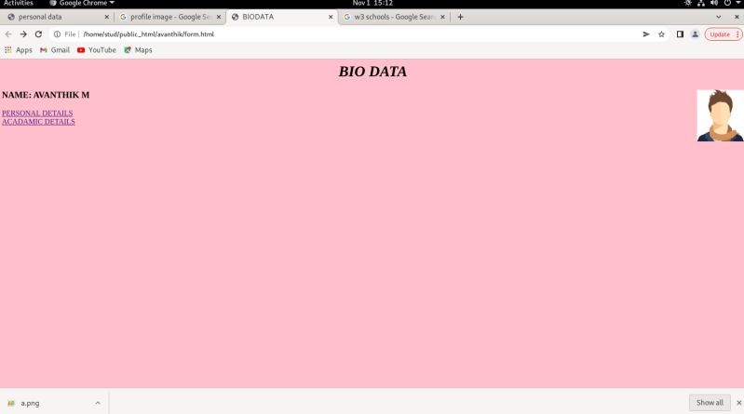

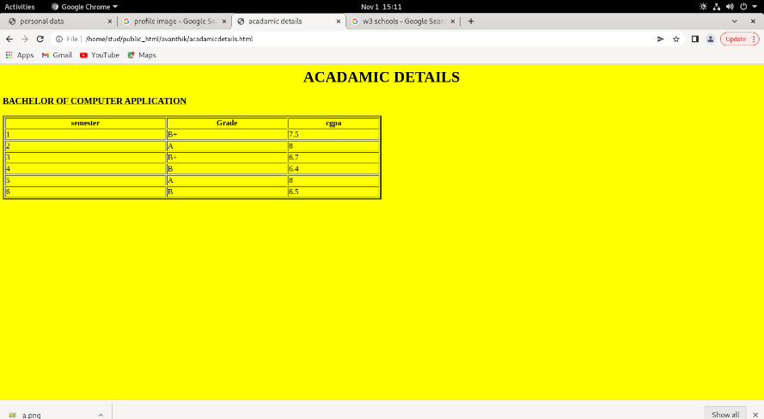

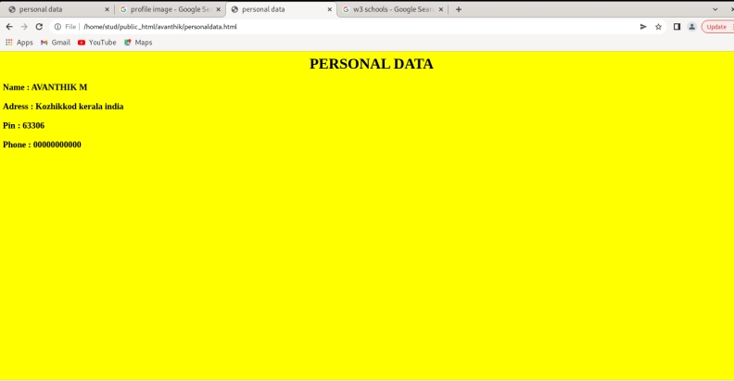

**AIM**: Design an application form for MCA course in FISAT using HTML.

**PROGRAM CODE:**

<html>

<head><title>form</title>

</head>

<body bgcolor="Lightskyblue">

<h1><b><center>FEDARAL INSTITUTE OF SCIENCE AND

TECHNOLOGY</center></b></h1>

<h2><center>MCA ADMISSION 2022</center></h2>

<form>

<label>First name:</label>

<input type="text" id="fname" name="fname"><br><br>

<label>Last name:</label>

<input type="text" id="lname" name="lname"><br><br>

Adress:

<br>

<textarea cols="40" rows="3" value="address">

</textarea> <br><br>

<label>Pin :</label>

<input type="text" id="pin" name="pin"><br><br>

<label>Mobile:</label>

<input type="text" id="mobile" name="mobile"><br><br>

<label>Email:</label>

<input type="email" id="email" name="fname"><br><br>

Gender:<br>

<input type="radio" name="male"/>Male<br>

<input type="radio" name="female"/>Female<br>

<input type="radio" name="other"/>Other<br><br>

DOB:<br>

<input type="date" name="dob"><br><br><br><br>

Course you study:<br>

<input type="radio" name="bca"/>BCA<br>

<input type="radio" name="bsc_cs"/>BSC CS<br>

<input type="radio" name="other"/>Other<br><br>

<center><input type="button" value="Submit">

<input type="button" value="reset">

</form>

</body>

</html>

**OUTPUT**

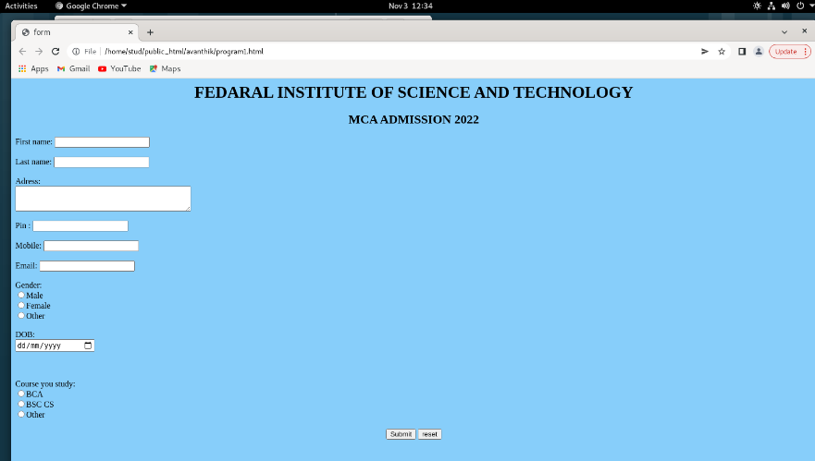

**AIM:** Create a HTML page with different types of frames such as floating frame, navigation frame & mixed frame.

**PROGRAM CODE:**

**Frame 1**

<html>

<head>

<title>HTML Frames</title>

</head>

<frameset cols = "30%,*">

<frame name = "f2" src = "C:\Users\lenovo\Downloads\html/f2.html" />

<frame name = "f3" src = "C:\Users\lenovo\Downloads\html/f3.html" />

<noframes>

<body>Your browser does not support frames.</body>

</noframes>

</frameset>

</html>

**Frame 2**

<html>

<head><title>FrameLeft</title></head>

<body><center>

<br><br><br><br><br><br><br><br>

<h1>Welcome!</h1>

<a href="f4.html" target="f3">Introduction</a><br>

<a href="f5.html" target="f3">Contents</a><br>

<a href="f6.html" target="f3">Description</a><br>

</center></body>

</html>

**Frame 3**

<html>

<head><title>Frameright</title></head>

<body><center>

<iframe src="C:\Users\lenovo\Downloads\html\f4.html" width="300" height="300">

</iframe>

<p align="bottom"><br><br><br><br><br><br><br><br><br><img src="logo.png"/></p>

</center></body>

</html>

**Frame 4**

<html>

<head><title>Frameright</title></head>

<body>

<p align="center"><br><br><br><img src="logo.png" align="center"/></p>

<p><br><br><br>FISAT Business School (FBS), established and managed by Federal Bank

Officers Association Educational Society (FBOAES), is a Management Institution under the

aegis of APJ Abdul Kalam Technological University and recognized by AICTE. FBOAES, formed

with the aim of establishing a Center of Excellence for professional education, is an initiative

of the Federal Bank Officers Association (FBOA), the sole representative body of the entire

officers in The Federal Bank with 35 years of yeomen services to its credit. This is a novel

venture from the Federal fraternity, which has operations spread over the entire span of the

country and overseas as well.

</p>

</body>

</html>

**Frame 5**

<html>

<head><title>Frameright</title></head>

<body style="background-image:logo2.png">

<p align="center"><br><br><br><img src="logo.png" align="center"/></p>

<br><br><br>

<p>Try clicking on the text labels:</p>

<form name="mca" action="f6.html">

<input type="radio" name="MCA" id="MCA" />

<label for="MCA">MCA</label>

<br />

<input type="radio" name="MBA" id="MBA" />

<label for="MBA">MBA</label><br>

<input type="submit" value="submit"></br>

</p>

</body>

</html>

**Frame 6**

<html>

<head><title>Frameright</title></head>

<body>

<p align="center"><br><br><br><img src="logo.png" align="center"/></p>

<p><br><br><br>The Federal Institute of Science and Technology (FISAT) is a self-financing

private engineering college established and promoted by the Federal Bank Officers’

Association Educational Society (FBOAES). The FBOAES is an initiative of the Federal Bank

Officers’ Association (FBOA), the sole representative body of all Federal Bank officers.

Federal Institute of Science and Technology (FISAT) occupies a unique position in South

India’s Professional Education Sector. FISAT has been designed and developed to become a

“Centre of Excellence” in professional education, with the motto “Focus on Excellence.”

Established in 2002, the college has carved a niche for itself in the education sector, as

evidenced by its students’ outstanding performance in academics, placements, and extracurricular

and co-curricular activities. FISAT has launched an ambitious plan to improve the

quality and value of education while also developing high-quality individuals. The institution

is accredited by the National Assessment and Accreditation Council (NAAC) with an ‘A’

grade. The National Board of Accreditation (NBA) has accredited five B.Tech programmes.

The institution is also ISO 9001:2015 certified. FISAT is located in Mookannoor, near

Angamaly in Ernakulam District, Kerala, the birthplace of The Federal Bank Ltd. founder,

Late K P Hormis, and the campus is named “Hormis Nagar” in his honour. FISAT is affiliated

with APJ Abdul Kalam Technological University (KTU) and is approved by the All India

Council for Technical Education (AICTE), New Delhi. FISAT offers seven B.Tech engineering

programmes, an MBA programme (with specialisations in Finance, Marketing, Human

Resource Management, Information System, Production & Operations Management, and

International Business), an MCA programme, five M.Tech programmes and PhD

programmes.

</p>

</body>

</html>

**OUTPUT**

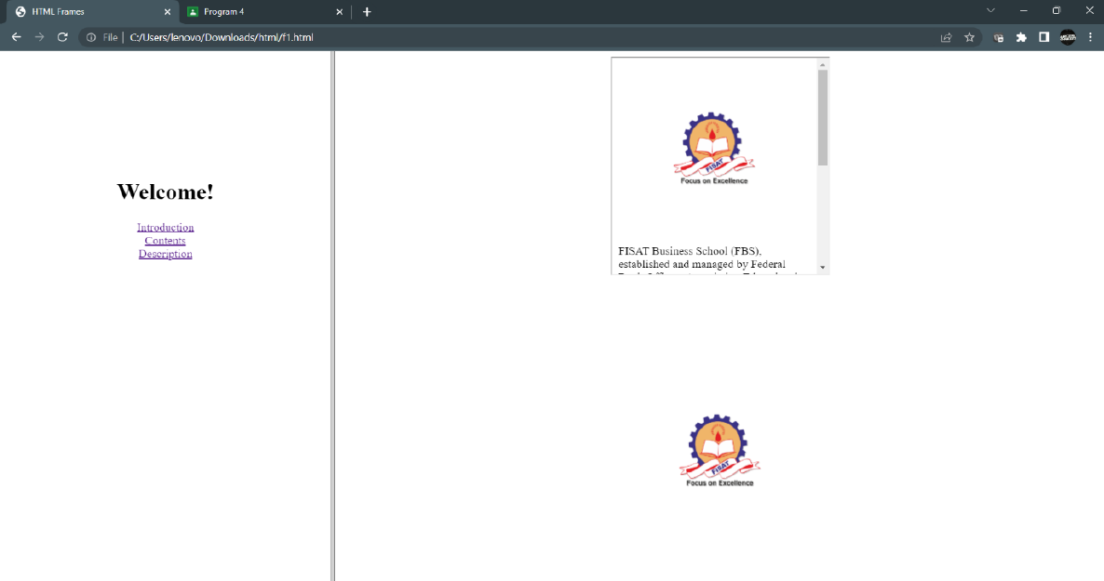

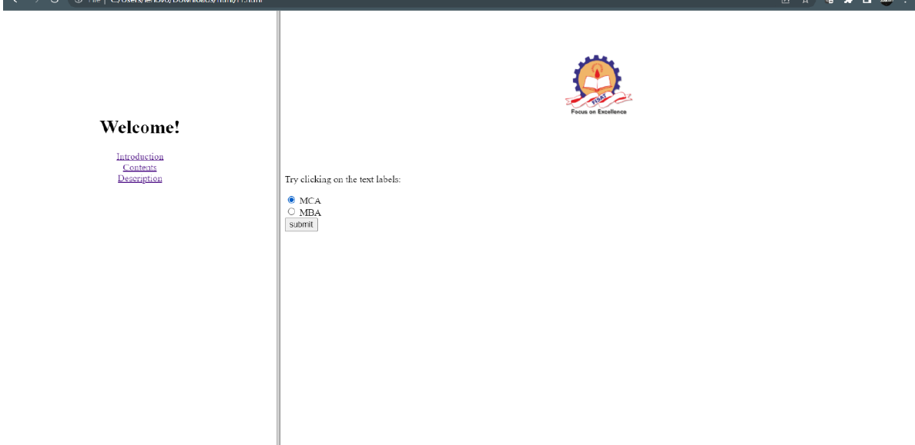

**AIM**: Analyze CSS by applying the different styles using inline, external & internal style sheets in a HTML file**.**

**PROGRAM CODE:**

Style.html

<html>

<head>

<link rel="StyleSheet" type="text/css" href="apply.css">

<style>

h3{

color:green;

font-size:28px;

font-family:"Times New Roman";

}

p{

color:grey;

font-family:"sans-serif";

}

</style>

</head>

<body>

<h1 align="center" style="color:blue;">KERALA</h1>

<h3>Description</h3>

<p>Kerala is a state on the Malabar Coast of India. It was formed on 1 November 1956, following the

passage of the States Reorganisation Act, by combining Malayalam-speaking regions of the erstwhile

regions of Cochin, Malabar, South Canara, and Thiruvithamkoor.Spread over 38,863 km2 (15,005 sq mi),

Kerala is the 21st largest Indian state by area. It is bordered by Karnataka to the north and northeast,

Tamil Nadu to the east and south, and the Lakshadweep Sea[16] to the west. With 33 million inhabitants

as per the 2011 census, Kerala is the 13th-largest Indian state by population. It is divided into 14 districts

with the capital being Thiruvananthapuram. Malayalam is the most widely spoken language and is also

the official language of the state.

</p>

</body>

</html>

Apply.css

body{

background-color : cyan;

}

h3{

color:green;

}

**OUTPUT**

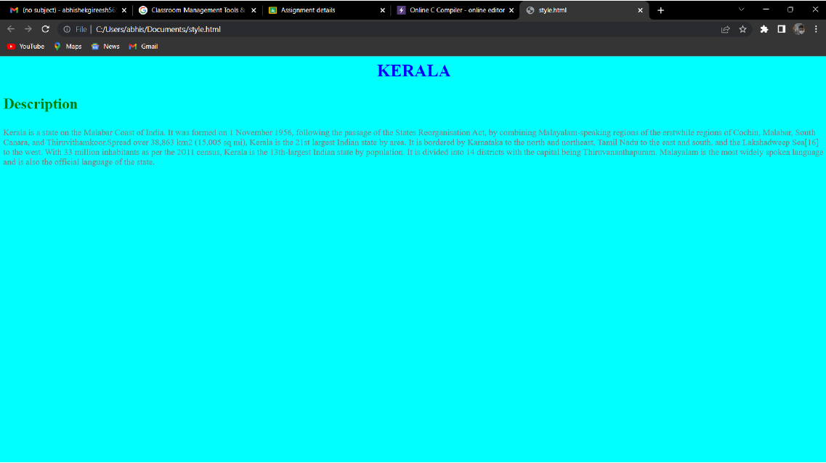

**AIM:** Create a HTML registration form and to validate the form using JavaScript code.

**PROGRAM CODE:**

VALIDATION

<html>

<head>

<script>

function validateForm() {

var x= document.forms["myForm"]["fname"].value;

var g = document.forms["myForm"]["gender"].value;

var y = document.forms["myForm"]["email"].value;

var z = document.forms["myForm"]["phone"].value;

var a = document.forms["myForm"]["address"].value;

if (x == "") {

alert("Name must be filled out");

return false;

}

if (g== "") {

alert("gender must be filled out");

return false;

}

if (y == "") {

alert("email must be filled out");

return false;

}

if (z== "") {

alert("phone must be filled out");

return false;

}

if (a== "") {

alert("address must be filled out");

return false;

}

if (isNaN(z)) {

document.getElementById("numberText").innerHTML = "Please enter Numeric value";

return false; }

}

</script>

</head>

<center>

<body bgcolor="powderblue">

<h1 align="center"><u>VALIDATION FORM</u></h1><br><br><br>

<form name="myForm" action="sub.html"

onsubmit="return validateForm()" method="post">

Name:<input type="text" name="fname"><br><br>

gender:<input type="radio" name="gender" value="male">male

<input type="radio" name="gender" value="female">female<br><br>

email:<input type="text" name="email"><br><br>

phone:<input type="text" name="phone"><br><br>

address:<textarea rows="4" cols="40" name="address"></textarea><br><br>

<span id="numberText"></span> <br />

<input type="submit" value="Submit">

</form>

</body>

</html>

SUBMIT

<html>

<head>

<title>WELCOME</title>

</html>

<body bgcolor="powderblue">

<h3 align="center">successfully completed the form</h3>

</body>

</html>

**OUTPUT**

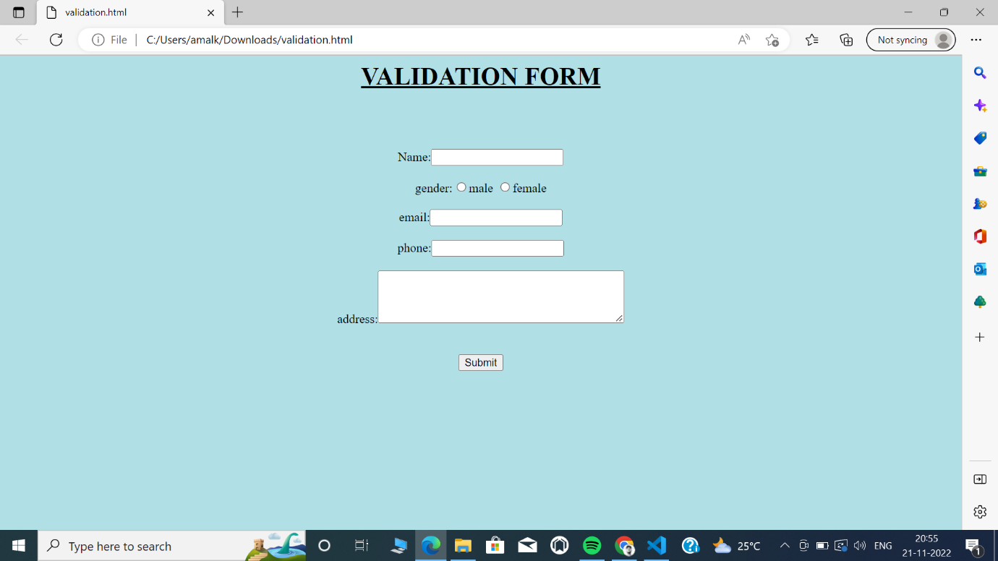

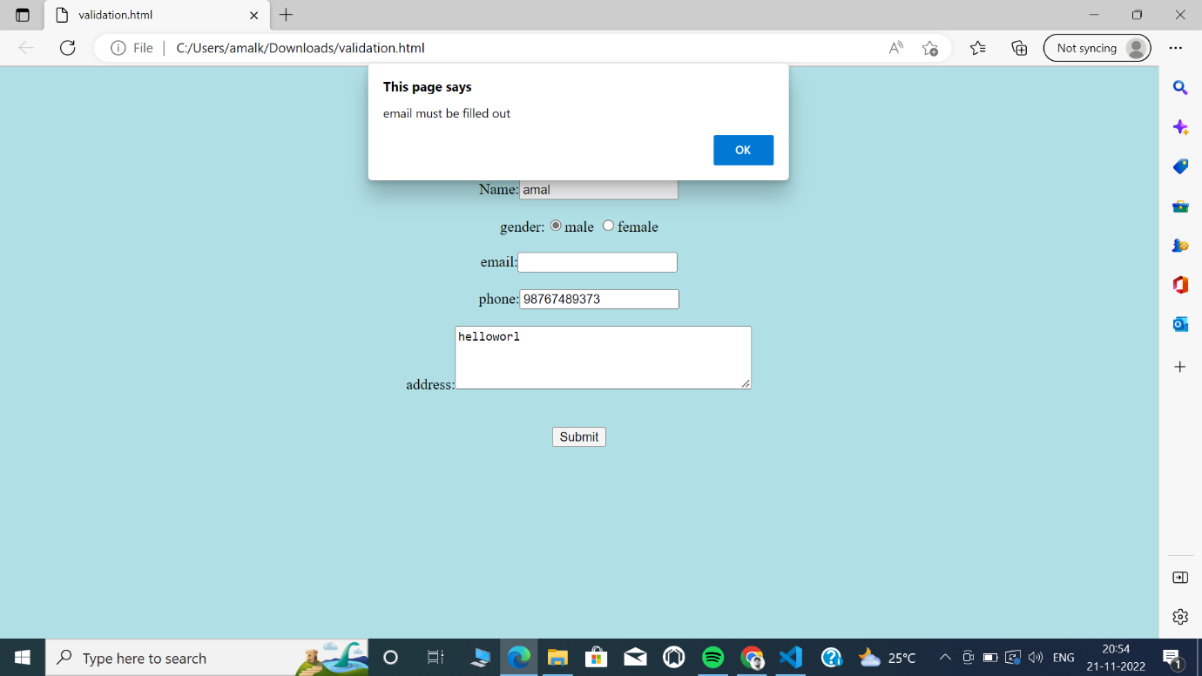

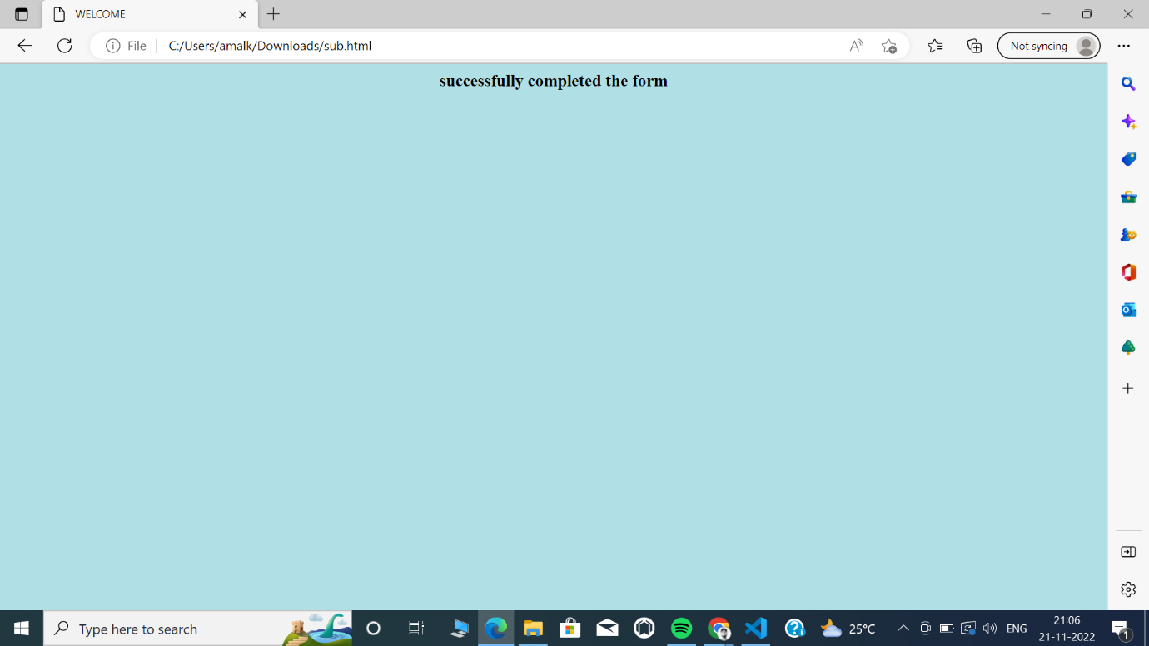

**AIM**: Create a HTML page to explain the use of various predefined functions in a string and math object in java script.

**PROGRAM CODE:**

<html>

<head></head>

<body bgcolor="lightblue">

<h1 align="center" style="color:blue;">Javascript String Functions</h2>

<h2>Length of a string</h2>

<p>The length of the string is:</p>

<p id="demo"></p>

<h2>The slice() Method</h2>

<p>The sliced part of the string is:</p>

<p id="slice"></p>

<h2>Substring()</h2>

<p>The substring() method extract a part of a string and returns the extracted parts in a new string:</p>

<p id="substrng"></p>

<h2>Replace()</h2>

<p>Replace "Morning" with "Evening" in the paragraph below:</p>

<button onclick="myFunction()">Try it</button>

<p id="repl">Good Morning!</p>

<h2>concat()</h2>

<p>The concat() method joins two or more strings:</p>

<p id="con"></p>

<h2>The trim() Method</h2>

<p id="trim1"></p>

<h2> split()</h2>

<p id="splt"></p>

<h1 align="center" style="color:red">Javascript Math Functions</h1>

<h2> Math.round()</h2>

<p>Math.round(x) returns the value of x rounded to its nearest integer:</p>

<p id="round"></p>

<h2> Math.ceil()</h2>

<p>Math.ceil() rounds a number up to its nearest integer:</p>

<p id="ceil"></p>

<h2> Math.floor()</h2>

<p>Math.floor(x) returns the value of x rounded down to its nearest integer:</p>

<p id="floor"></p>

<h2>Math.trunc()</h2>

<p>Math.trunc(x) returns the integer part of x:</p>

<p id="trunc"></p>

<h2>Math.sign()</h2>

<p>Math.sign(x) returns if x is negative, null or positive:</p>

<p id="sign"></p>

<h2> Math.pow()</h2>

<p>Math.pow(x,y) returns the value of x to the power of y:</p>

<p id="pow"></p>

<h2> Math.sqrt()</h2>

<p>Math.sqrt(x) returns the square root of x:</p>

<p id="sqrt"></p>

<h2>Math.log()</h2>

<p>Math.log() returns the natural logarithm of a number:</p>

<p id="log"></p>

<script>

let text = "ABCDEFGHIJKLMNOPQRSTUVWXYZ";

document.getElementById("demo").innerHTML = text.length;

let a = "Apple, Banana, Kiwi";

let part = a.slice(7,13);

document.getElementById("slice").innerHTML = part;

let str = "Apple, Banana, Kiwi";

document.getElementById("substrng").innerHTML = str.substring(7,13);

function myFunction() {

let r = document.getElementById("repl").innerHTML;

document.getElementById("repl").innerHTML =r.replace("Morning","Evening");

}

let x = "Hello";

let y = "World!";

let z = x.concat(" ",y);

document.getElementById("con").innerHTML = z;

let text1 = " Hello World! ";

let text2 = text1.trim();

document.getElementById("trim1").innerHTML =

"Length text1 = " + text1.length + "<br>Length text2 = " + text2.length;

let k = "Hello";

const Arr = k.split("");

k = "";

for (let i = 0; i < Arr.length; i++) {

k += Arr[i] + "<br>"

}

document.getElementById("splt").innerHTML = k;

document.getElementById("round").innerHTML = Math.round(5.7);

document.getElementById("ceil").innerHTML = Math.ceil(3.2);

document.getElementById("floor").innerHTML = Math.floor(3.7);

document.getElementById("trunc").innerHTML = Math.trunc(7.8);

document.getElementById("sign").innerHTML = Math.sign(10);

document.getElementById("pow").innerHTML = Math.pow(3,3);

document.getElementById("sqrt").innerHTML = Math.sqrt(64);

document.getElementById("log").innerHTML = Math.log(1);

</script>

</body>

</html>

**OUTPUT**

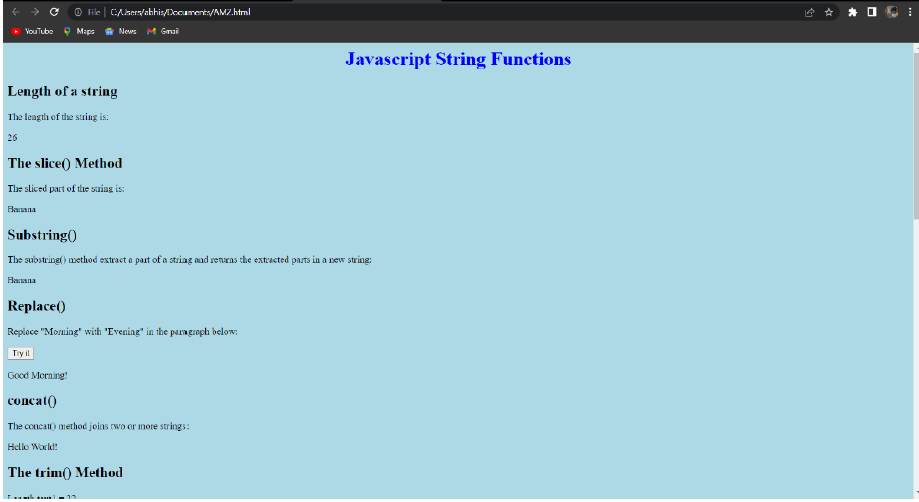

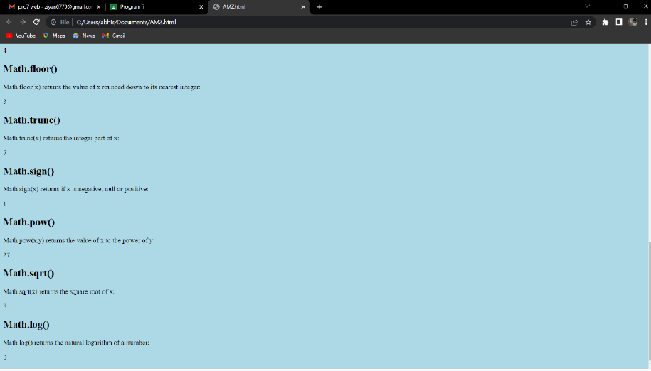

**AIM:**Create a HTML page to change the background color for every  
click of a button using JavaScript Event Handling.

**PROGRAM CODE:**

<!DOCTYPE HTML>

<html>

<head>

<title>

CHANGING BACKGROUND COLOUR

</title>

</head>

<body style = "text-align:center;">

<h1 style = "color:RED;" >

WELCOME!!

</h1>

<button type="button" id="color-button" onclick="changeBg()">CLICK HERE

</button>

<br>

<script>

document.writeln("PRESS THE BUTTON");

const pageBody = document.querySelector("body");

function changeBg()

{

let color = '#'+(Math.random()*0xFFFFFF<<0).toString(16);

pageBody.style.background = color;

}

</script>

</body>

</html>

**OUTPUT**

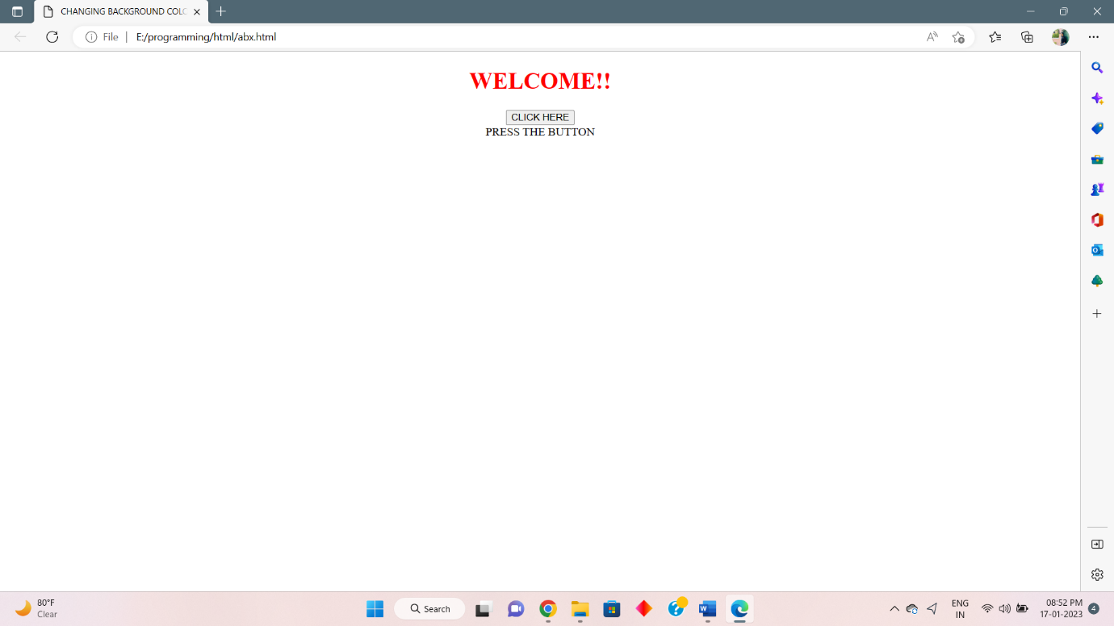

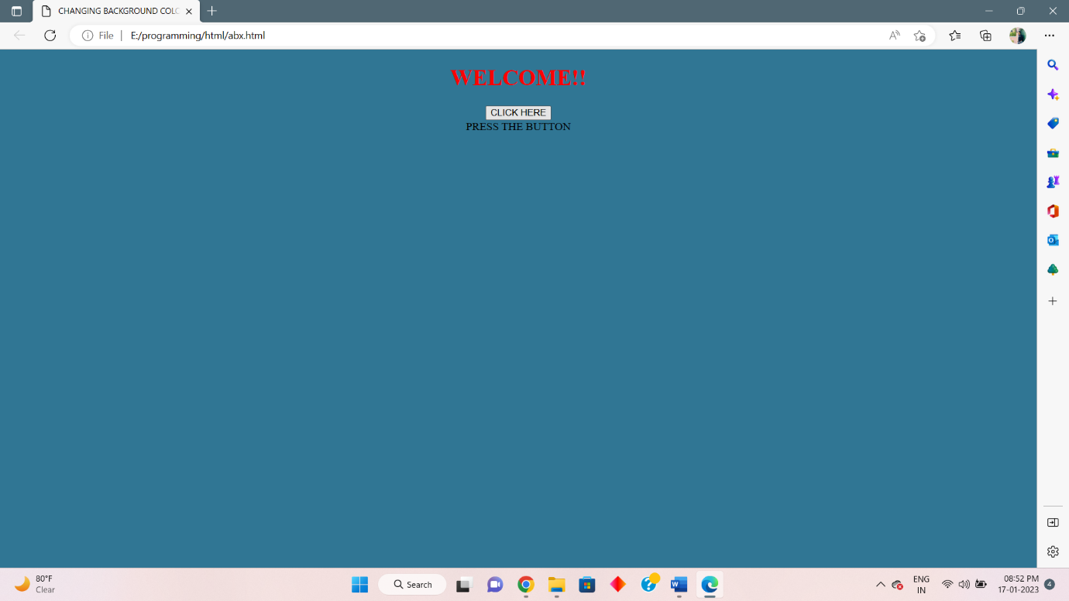

**AIM:** Compose Electricity bill from user input based on a given tariff using PHP.

**PROGRAM CODE:**

<html>

<head>

<title>Electricity Bill</title>

</head>

<body>

<h3 align="center">Electricity Bill</h3>

<table align="center">

<form method="post" action="">

<tr><td>Consumer ID</td><td> <input type="number" name="con" placeholder="consumer id" required></td></tr><br>

<tr><td>Consumer Name</td><td> <input type="text" name="name" placeholder="consumer name" required></td></tr><br>

<tr><td>Enter Units</td><td> <input type="number" name="un" placeholder="no.of units used" required></td></tr><br>

<tr><td></td><td><input type="submit" name="submit" value="submit"></tr><br>

<?php

if (isset($_POST['submit']))

{

$cid=$_POST['con'];

$cname=$_POST['name'];

?>

<tr><td><?php echo '<b>Consumer ID </b>: '.$cid; ?> </td></tr>

<tr><td><?php echo '<b>Consumer Name </b>: '.$cname; ?> </td></tr>

<tr><td>

<?php

$unit=$_POST['un'];

if ($unit>=50)

 {

 $bill=$unit*3.15;

 echo '<b>Electricity Bill</b> : '.$bill;

 }

elseif ($unit>50 && $unit<=150)

 {

 $bill=$unit*3.70;

 echo '<b>Electricity Bill</b> : ',$bill;

 }

elseif ($unit>150 && $unit<=200)

 {

 $bill=$unit*6.40;

 echo '<b>Electricity Bill</b> : ',$bill;

 }

else

 {

$bill=$unit*7.60;;

echo '<b>Electricity Bill</b> : ',$bill;

 }

}

else

{

echo '<script>alert("try again")</script>';

}

?></td></tr>

</form>

</body>

</html>

**OUTPUT**

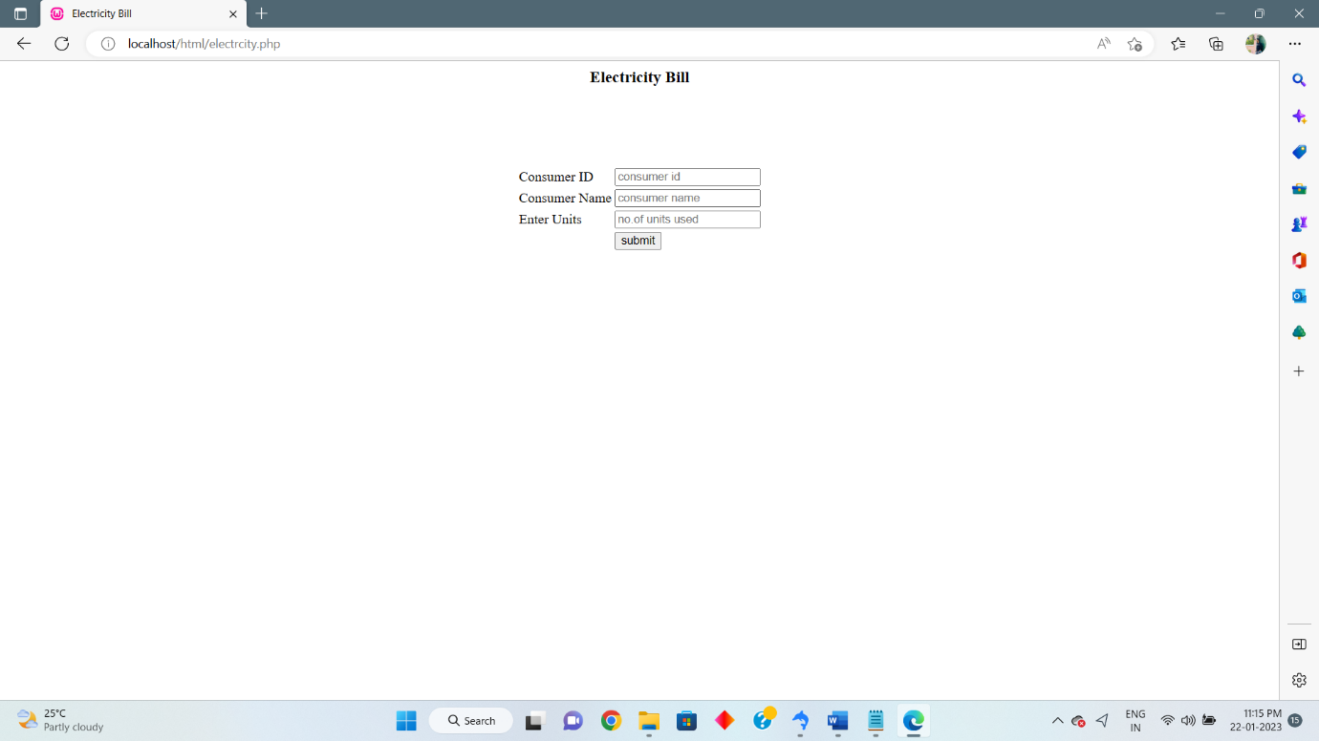

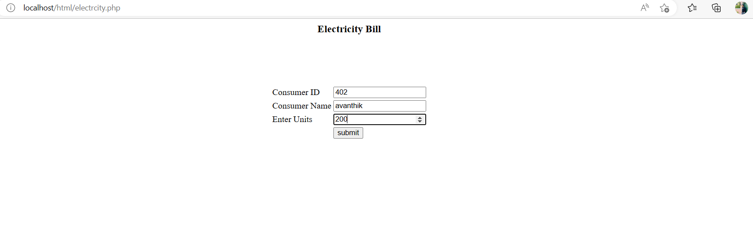

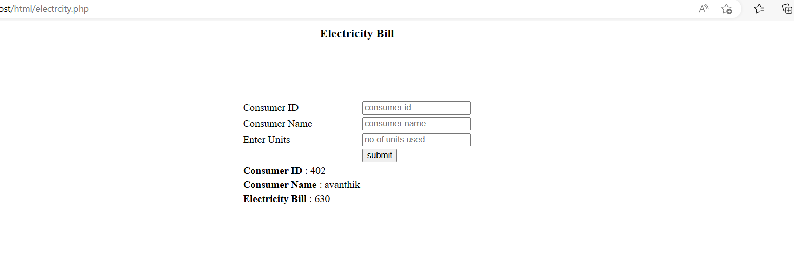

**AIM**: Build a PHP code to store name of students in an array and display it using print_r  
function. Sort and Display the same using asort & arsort functions.

**PROGRAM CODE:**

<html>

<head>

<title>Program 10</title>

</head>

<body>

<h2>Student Names.</h2>

<?php

if(!isset($_POST['submit']))

{

?>

<form name="billform" method="POST" action="p10.php">

<strong>Enter Name 1: </strong><input type="text" name="name1" required>

<br><br>

<strong>Enter Name 2: </strong><input type="text" name="name2" required>

<br><br>

<strong>Enter Name 3: </strong><input type="text" name="name3" required>

<br><br>

<strong>Enter Name 4: </strong><input type="text" name="name4" required>

<br><br>

<strong>Enter Name 5: </strong><input type="text" name="name5" required>

<br><br>

<input type="submit" name="submit" value="Submit">

<input type="reset" name="reset" value="Reset">

</form>

<?php

}

else

{

$names['Name1']=$_POST['name1'];

$names['Name2']=$_POST['name2'];

$names['Name3']=$_POST['name3'];

$names['Name4']=$_POST['name4'];

$names['Name5']=$_POST['name5'];

?>

<strong>Names: </strong>

<?php

print_r($names);

?>

<br><br>

<strong>Names in ascending order: </strong>

<?php

asort($names);

print_r($names);

?>

<br><br>

<strong>Names in descending order: </strong>

<?php

arsort($names);

print_r($names);

}

?>

</body>

</html>

**Output**

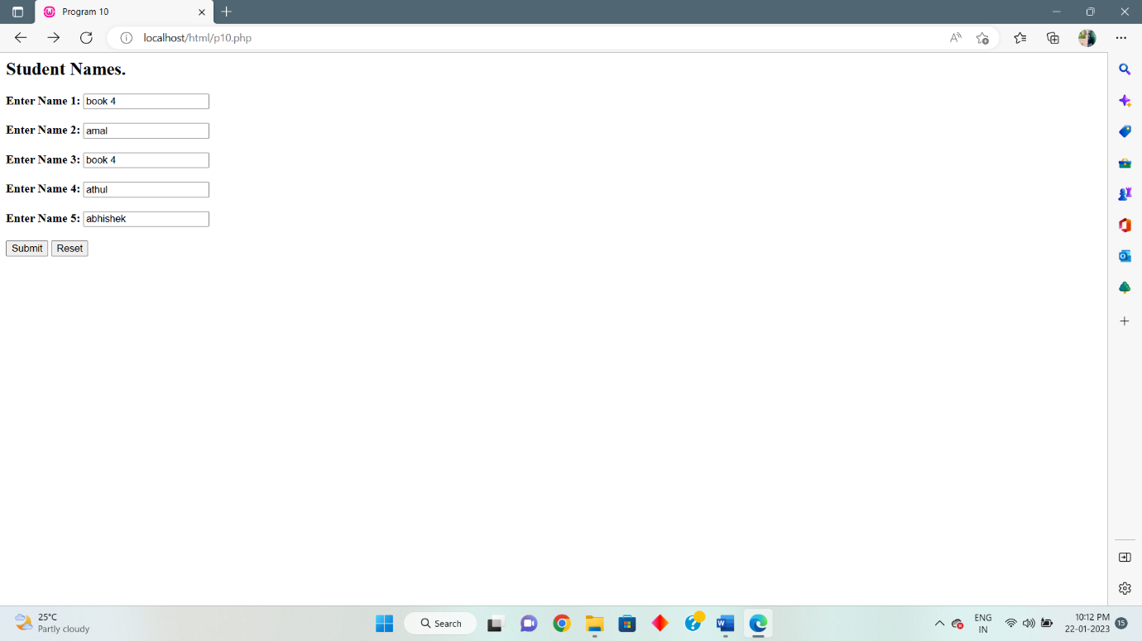

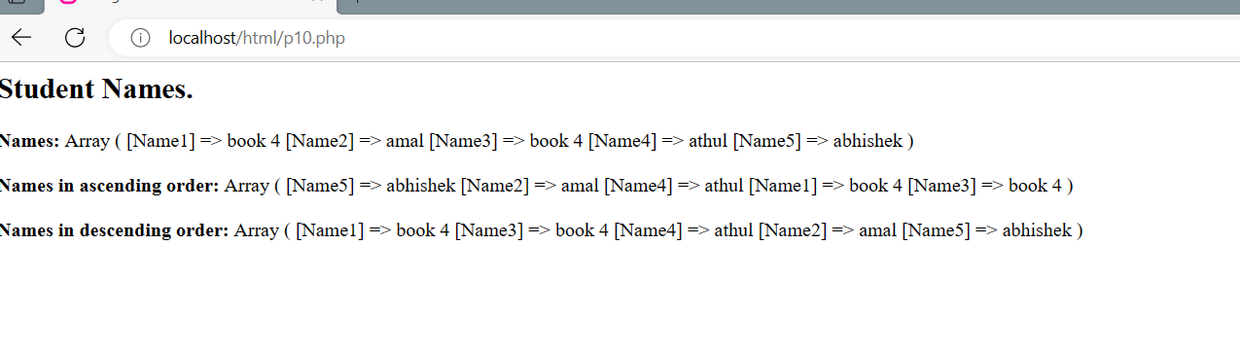

**AIM**: Build a PHP code to store name of Indian Cricket players in an array and display  
the same in HTML table.

**PROGRAM CODE:**

<html>

<head>

<title>Program 11</title>

</head>

<body>

<h2>Indian Cricket Players.</h2>

<form name="form1" method="POST" action="action11.php">

<strong>Enter Name Of Cricket Player 1: </strong><input type="text" name="name1" required>

<br><br>

<strong>Enter Name Of Cricket Player 2: </strong><input type="text" name="name2" required>

<br><br>

<strong>Enter Name Of Cricket Player 3: </strong><input type="text" name="name3" required>

<br><br>

<strong>Enter Name Of Cricket Player 4: </strong><input type="text" name="name4" required>

<br><br>

<strong>Enter Name Of Cricket Player 5: </strong><input type="text" name="name5" required>

<br><br>

<input type="submit" name="submit" value="Submit">

<input type="reset" name="reset" value="Reset">

</form>

</body>

</html>

Action11.php:

<?php

$names[0]=$_POST['name1'];

$names[1]=$_POST['name2'];

$names[2]=$_POST['name3'];

$names[3]=$_POST['name4'];

$names[4]=$_POST['name5'];

$length=count($names);

echo "<h2>Indian Cricket Players.</h2>";

echo "<table border='1'>";

echo "<tr>";

echo "<th width='100'>Sl.No.</th>";

echo "<th width='100'>Name</th>";

echo "</tr>";

for($i=0;$i<$length;$i++)

{

echo "<tr>";

echo "<td>".($i+1)."</td>";

echo "<td>".$names[$i]."</td>";

echo "</tr>";

}

echo "</table>";

?>

**OUTPUT**

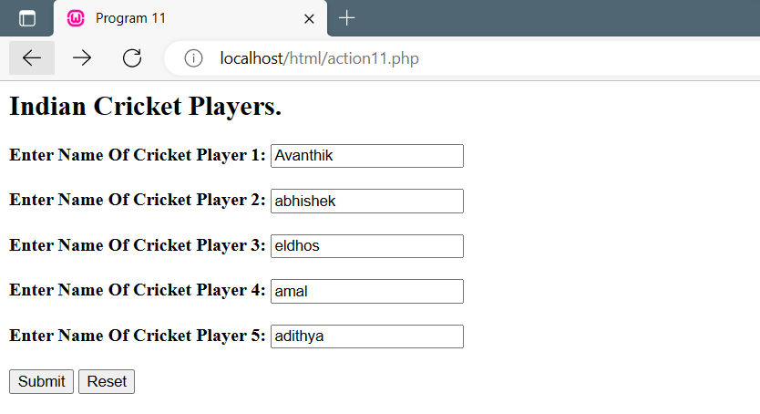

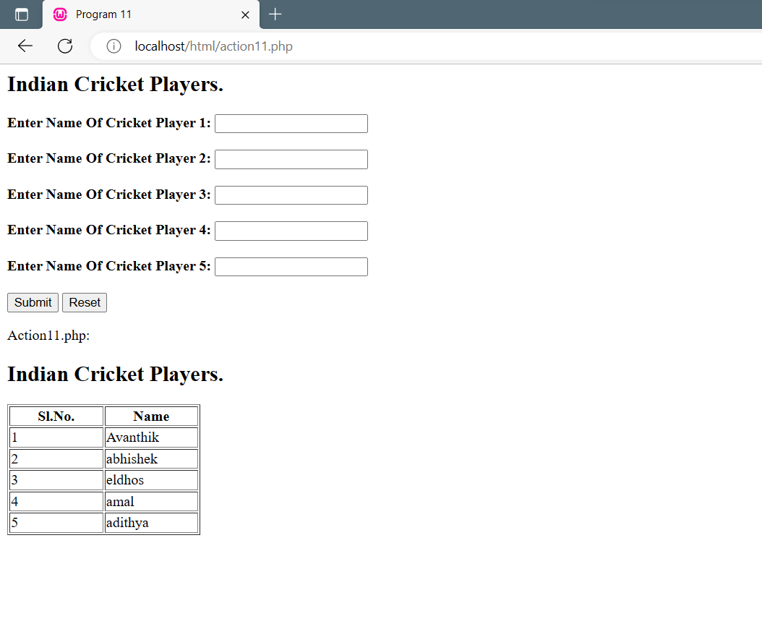

**AIM:** Outline a registration form using PHP and do necessary validations**.**

**PROGRAM CODE:**

HTML:

<html>

<head>

<title>Registration Form</title>

</head>

<body>

<br>

<h2 align="center">Registration Form</h2>

<br>

<form name="form1" method="post" action="p12.php">

<strong>Name: </strong><input type="text" name="name">

<br><br>

<strong>Address: </strong><input type="text" name="address">

<br><br>

<strong>Gender: </strong><input type="text" name="gender">

<br><br>

<strong>Age: </strong><input type="text" name="age">

<br><br>

<strong>Phone: </strong><input type="text" name="phone">

<br><br><br>

<input type="submit" name="submit" value="Submit">

<input type="reset" name="reset" value="Reset">

</form>

</body>

</html>

PHP:

<?php

$name=$_POST['name'];

$address=$_POST['address'];

$gender=$_POST['gender'];

$age=$_POST['age'];

$phone=$_POST['phone'];

if($name==NULL)

{

echo '<script>alert("Please Fill Out Your Name!"); window.history.back();</script>';

return false;

   }

if($address==NULL)

{

echo '<script>alert("Please Fill Out Your Address!"); window.history.back();</script>';

return false;

}

if($gender==NULL)

{

echo '<script>alert("Please Enter Your Gender!"); window.history.back();</script>';

return false;

}

if($age==NULL)

{

echo '<script>alert("Please Enter Your Age!"); window.history.back();</script>';

return false;

}

else if (!ctype_digit($age))

{

echo '<script>alert("Please Enter A Numeric Value For Age!"); window.history.back();</script>';

return false;

}

if($phone==NULL)

{

echo '<script>alert("Please Enter Your Phone Number!"); window.history.back();</script>';

return false;

}

else if (!ctype_digit($phone))

{

echo '<script>alert("Please Enter Numeric Values For Phone Number!"); window.history.back();</script>';

return false;

}

else if (strlen($phone)!==10)

{

echo '<script>alert("Please Enter A 10 Digit Phone Number!"); window.history.back();</script>';

return false;

}

else

{

echo '<script>alert("Successfully Submitted!"); window.history.back();</script>';

}

?>

**OUTPUT**

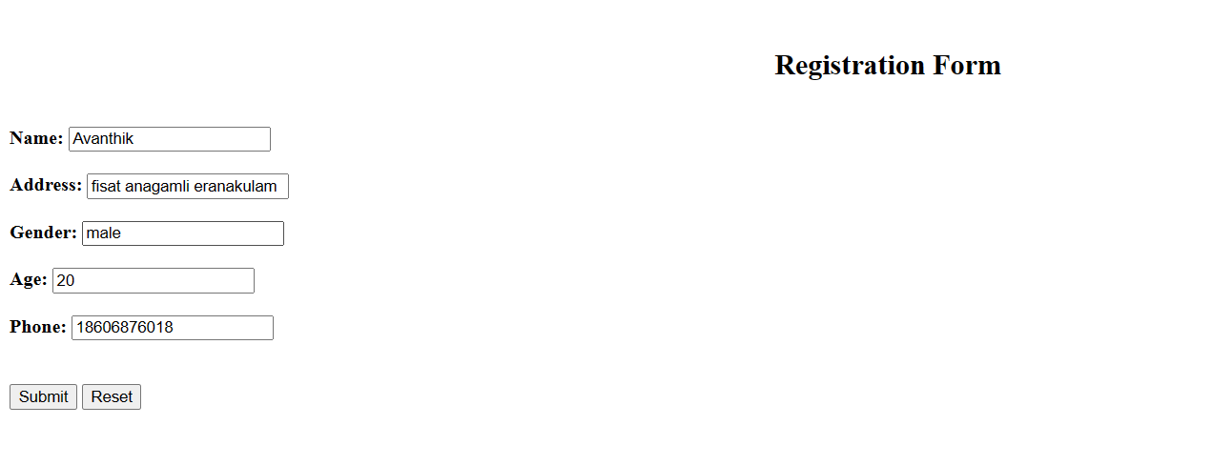

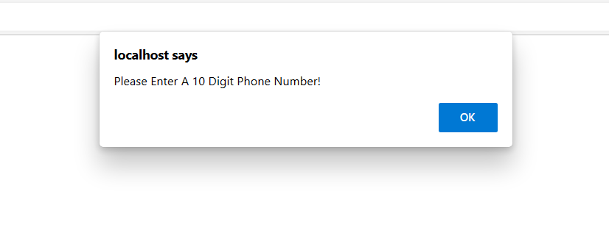

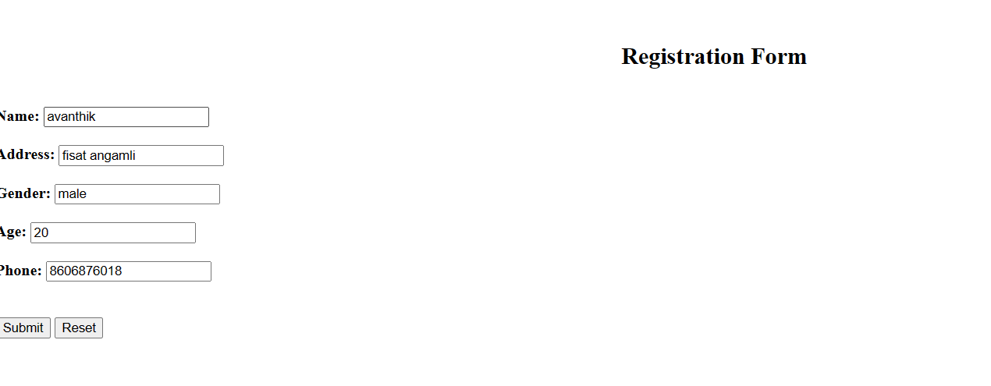

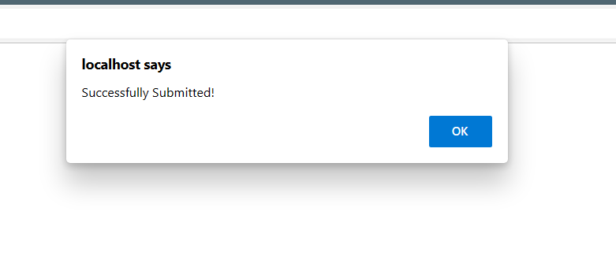

**AIM:** Develop a PHP program to connect to a database and add data to the employee table and retrieve data from the table and  
show the retrieved details in a neat format.

**PROGRAM CODE:**

**empdetails.php:**

<?php

$con = new mysqli("localhost", "fisat", "fisat", "fisatdb");

if($con==false)

{

echo "failed to connect";

}

else

{

echo "connected";

}

if(isset($_POST['submit']))

{

$id=$_POST['emp_id'];

$name=$_POST['emp_name'];

$age=$_POST['age'];

$department=$_POST['dept'];

$sql = "INSERT INTO employee(emp_id,emp_name,age,dept) VALUES($id,'$name',$age,'$department')";

if ($con->query($sql) === true) {

echo 'New row added.';

} else {

echo "ERROR: Could not execute query: $sql. ".$con->error;

}

}

$con->close();

?>

**empfetch.php:**

<?php

$con = new mysqli("localhost", "fisat", "fisat", "fisatdb");

if($con==false)

{

echo "failed to connect";

}

else

{

echo "connected";

}

$sql = "SELECT * from employee";

if ($result = $con->query($sql))

{ if ($result->num_rows > 0) {

while($row = $result->fetch_array()) {

?>

<?php

echo $row[0] . ":" . $row[1] . "\n";

}

$result->close();

} else {

echo "No records matching your query were found.";

}

} else {

echo "ERROR: Could not execute $sql. " . $con->error;

} $con->close();

?>

**employee.php:**

<html>

<head>

<title> Employee details </title>

</head>

<body>

<h1 align="center" > <u> Employee details</u>  </h1>

<table align="'center" >

<form method="post" action ="empdetails.php">

<tr>

<th> Employee Id :<th>

<td> <input type="number" name="emp_id" size="'40" > </td> </tr>

<tr><th> Employee Name:<th>

<td> <input type="text" name="emp_name" size="'40" > </td> </tr>

<tr><th> Age :<th>

<td> <input type="number" name="age" size="'70" > </td>

<tr><th> Department:<th>

<td> <input type="text" name="dept" size="'40" > </td> </tr>

<tr><td><input type="submit" name="submit" value="submit"></td>

<td><input type="Reset" name="reset" value="reset"></td></tr></table>

</form>

</body>

</html>

**empfull.php:**

<html>

<head>

<title>employee</title>

</head>

<body>

<h1 align="center">EMPLOYEE</h1>

<a href="employee.php">Add Employee</a><br>

<a href="empfetch.php">Employee Details</a>

</body>

</html>

**OUTPUT**

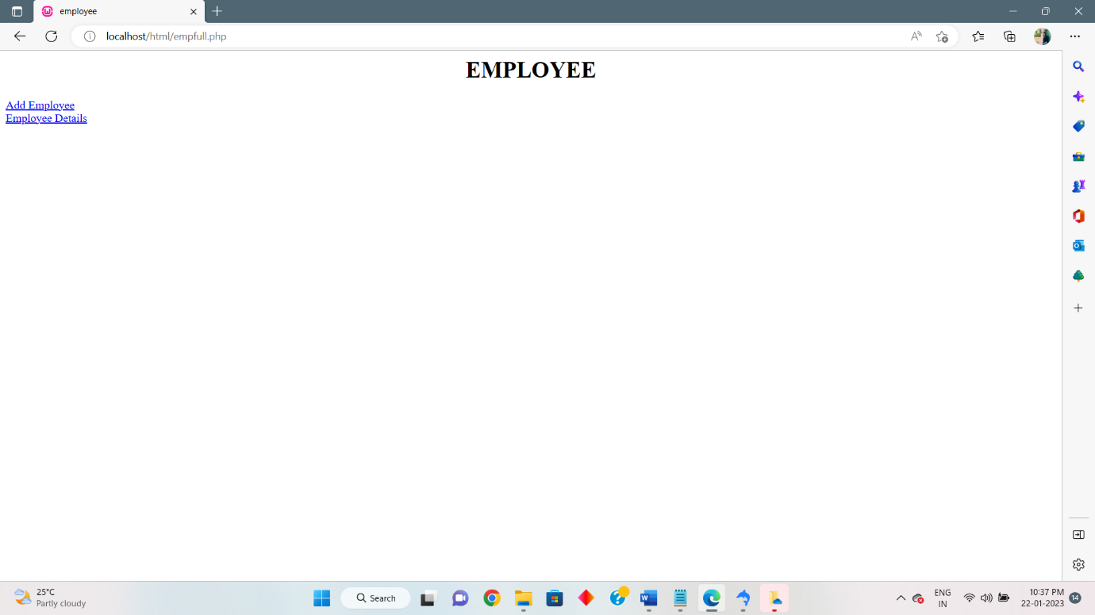

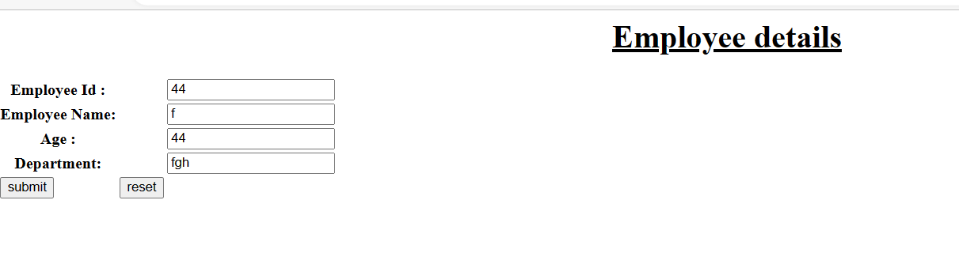

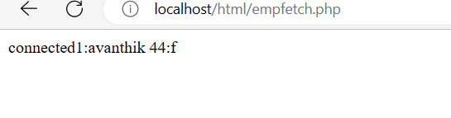

**Database**

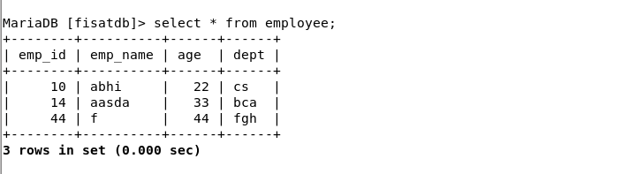

**AIM**: Using PHP and MySQL, develop a program to accept book information viz. Accession number, title, authors, edition and publisher from a web page and store the information in a database and to search for a book with the  
title specified by the user and to display the search results with proper headings**.**

**PROGRAM CODE:**

**p14.html:**

<html>

<head>

<title>Program 14</title>

</head>

<body>

<h2>Employee Details.</h2>

<form name="form1" method="POST" action="action.php">

<strong>Enter Accsession number: </strong><input type="number" name="an" required>

<br><br>

<strong>Enter Title: </strong><input type="text" name="title" required>

<br><br>

<strong>Enter author name: </strong><input type="text" name="aname" required>

<br><br>

<strong>Enter edition: </strong><input type="number" name="edition" required>

<br><br>

<strong>Enter publisher: </strong><input type="text" name="publish" required>

<br><br>

<input type="submit" name="submit" value="Submit">

<input type="reset" name="reset" value="Reset">

</form>

</body>

</html>

**a.html:**

<html>

<head>

<title>Program 14</title>

</head>

<body align="center">

<br>

<h2>Book Information System.</h2>

<br>

<a href="src.html"><button>Search For a Book</button></a>

<a href="p14.html"><button>New Book Entry</button></a>

</body>

</html>

**src.html:**

<html>

<head>

<title>Program 14</title>

</head>

<body>

<h2 align="center">Book Information System.</h2>

<h2>Search Book.</h2>

<form name="form1" method="POST" action="search.php">

<strong>Enter Book Title: </strong><input type="text"

name="title"required>

<br><br>

<input type="submit" name="submit" value="Submit">

<input type="reset" name="reset" value="Reset">

</form>

<br><br>

</body>

</html>

**action.php:**

<?php

$con= new mysqli("localhost","fisat","fisat","fisatdb");

if($con===false)

{

die("ERROR: Could not connect. " . mysqli_connect_error());

}

else

{

$access=$_POST['an'];

$title=$_POST['title'];

$author=$_POST['aname'];

$edit=$_POST['edition'];

$pub=$_POST['publish'];

$id=rand(1000,9999);

$sql = "INSERT INTO ava_book (id,access,title,author,edit,pub) VALUES ('$id','$access','$title','$author','$edit','$pub')";

if ($con->query($sql) === true)

{

$sql1 = "select * FROM ava_book";

if ($result=$con->query($sql1))

{

if (($result->num_rows)>0)

{

echo "<h2>BOOK INFORMATION.</h2>";

echo "<table border='1'>";

echo "<tr>";

echo "<th width='100'>ID</th>";

echo "<th width='100'>Accession No</th>";

echo "<th width='100'>Title</th>";

echo "<th width='100'>Author Name</th>";

echo "<th width='100'>Edition</th>";

echo "<th width='100'>Publisher</th>";

echo "</tr>";

while($row = $result->fetch_array())

{

echo "<tr>";

echo "<td>".$row[0]."</td>";

echo "<td>".$row[1]."</td>";

echo "<td>".$row[2]."</td>";

echo "<td>".$row[3]."</td>";

echo "<td>".$row[4]."</td>";

echo "<td>".$row[5]."</td>";

echo "</tr>";

}

echo "</table>";

$result->close();

}

}

else

{

echo "ERROR: Could not execute query: $sql1. " . $con->error;

}

}

else

{

echo "ERROR: Could not execute query: $sql. " . $con->error;

}

}

$con->close();

?>

**search.php:**

<?php

$con= new mysqli("localhost","fisat","fisat","fisatdb");

if($con===false)

{

die("ERROR: Could not connect. " . mysqli_connect_error());

}

else

{

$title=$_POST['title'];

$sql1 = "SELECT * FROM ava_book WHERE title LIKE '%$title%'";

if ($result=$con->query($sql1))

{

if (($result->num_rows)>0)

{

echo "<h2>Book Details.</h2>";

echo "<table border='1'>";

echo "<tr>";

echo "<tr>";

echo "<th width='100'>ID</th>";

echo "<th width='100'>Accession No</th>";

echo "<th width='100'>Title</th>";

echo "<th width='100'>Author Name</th>";

echo "<th width='100'>Edition</th>";

echo "<th width='100'>Publisher</th>";

echo "</tr>";

while($row = $result->fetch_array())

{

echo "<tr>";

echo "<td>".$row[0]."</td>";

echo "<td>".$row[1]."</td>";

echo "<td>".$row[2]."</td>";

echo "<td>".$row[3]."</td>";

echo "<td>".$row[4]."</td>";

echo "<td>".$row[5]."</td>";

echo "</tr>";

}

echo "</table>";

$result->close();

}

}

else

{

echo "ERROR: Could not execute query: $sql1. " . $con->error;

}

}

$con->close();

?>

**OUTPUT**

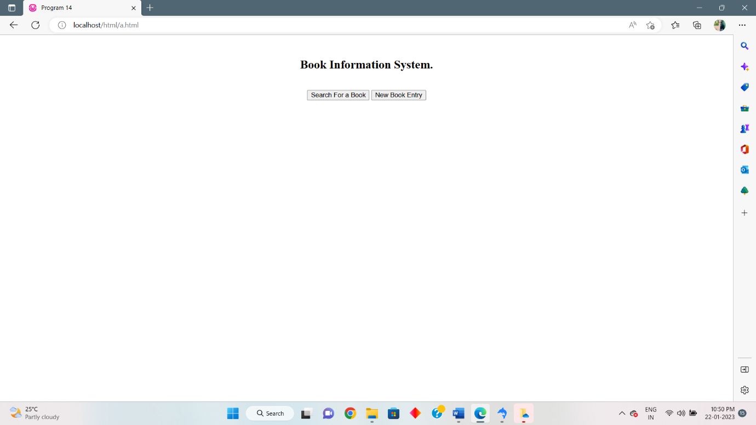

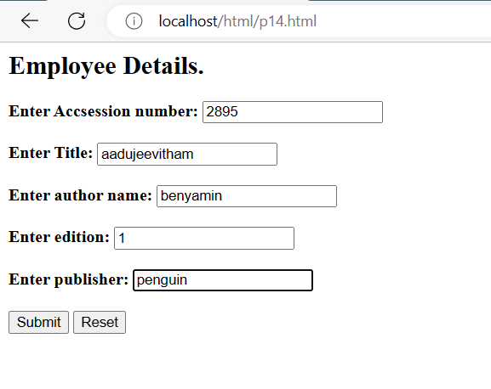

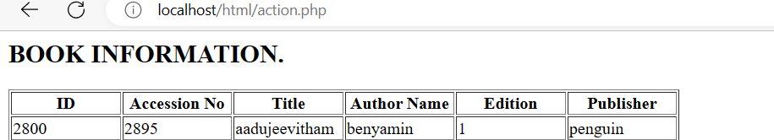

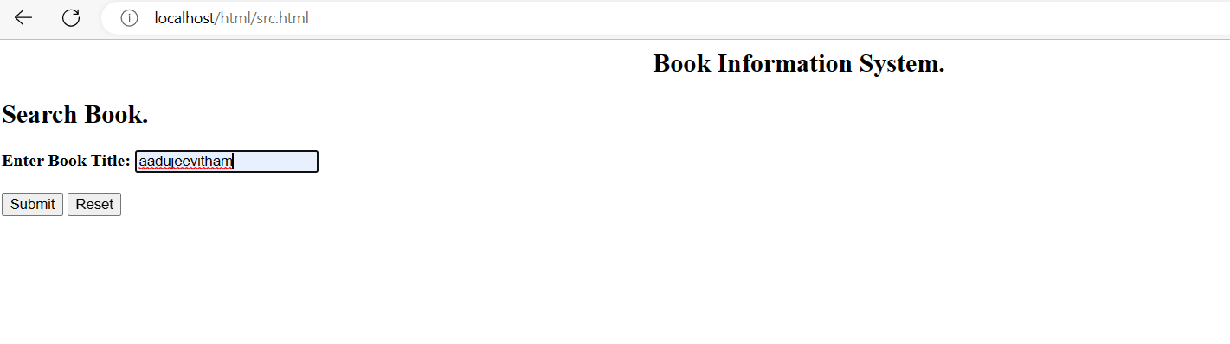

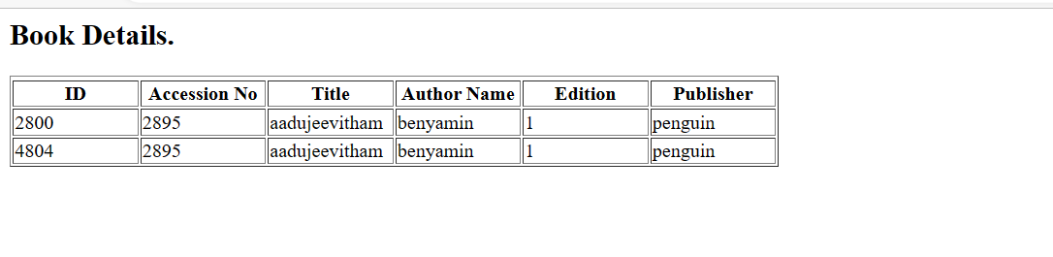

**Database**

**AIM:** Using PHP and MySQL, develop a program to collect airline details and display all the airlines between a particular source and destination.

**PROGRAM CODE:**

**prog15.html:**

<html>

<head>

<title>airline</title>

</head>

<body align="center">

<br>

<h2>AIRLINE INFORMATION SYSTEM</h2><br>

<a href="add.html"><button>ADD AIRLINE DETAILS</button></a>

<a href="src.html"><button>SEARCH AIRLINE DETAILS</button></a>

</body>

</html>

add.html:

<html>

<head>

<title>add airline</title>

</head>

<body>

<form name="form1" action="action15.php" method="POST">

<h2>Enter Airline Details</h2><br><br>

<strong>AIRLINE ID: </strong><input type="number" name="id"><br><br>

<strong>AIRLINE NAME: </strong><input type="text" name="name"><br><br>

<strong>DEPARTURE FROM: </strong><input type="text" name="depfrom"><br><br>

<strong>DEPARTURE TIME: </strong><input type="number" name="deptime"><br><br>

<strong>ARRIVAL TIME: </strong><input type="number" name="aritime"><br><br>

<strong>ARRIVAL PLACE: </strong><input type="text" name="ariplace"><br><br>

<input type="submit" name="Submit">

<input type="reset" name=“Reset">

</form>

</body>

</html>

**src.html:**

<html>

<head>

<title>search</title>

</head>

<body>

<form name="form2" action="search.php"method="POST">

<h2>SEARCH AIRLINE</h2><br>

<strong>DEPARTURE FROM: </strong><input type="text" name="txt"><br><br>

<strong>ARRIVAL PLACE: </strong><input type="text" name="txt1"><br><br>

<input type="submit" name="Submit">

<input type="reset" name=“Reset">

</form>

</body>

</html>

**action15.php:**

<?php

$id=$_POST['id'];

$name=$_POST['name'];

$depfrom=$_POST['depfrom'];

$deptime=$_POST['deptime'];

$airtime=$_POST['aritime'];

$airplace=$_POST['ariplace'];

$con=new mysqli("localhost","fisat","fisat","fisatdb");

if($con==false)

{

echo "Failed to connect";

}

else

{

$sql="INSERT INTO cliff_airline VALUES('$id','$name','$depfrom',$deptime,$airtime,'$airplace')";

if($con->query($sql))

{

$sql="SELECT * FROM cliff_airline";

if($result=$con->query($sql))

{

if($result->num_rows>0)

{

echo "<h2>Book Details.</h2>";

echo "<table border='1'>";

echo "<tr>";

echo "<th width='100'>Airline ID</th>";

echo "<th width='100'>Name</th>";

echo "<th width='100'>Departure From</th>";

echo "<th width='100'>Departure Time</th>";

echo "<th width='100'>Arrival Time</th>";

echo "<th width='100'>Arrival Place</th>";

echo "</tr>";

while($row = $result->fetch_array())

{

echo "<tr>";

echo "<td>".$row[0]."</td>";

echo "<td>".$row[1]."</td>";

echo "<td>".$row[2]."</td>";

echo "<td>".$row[3]."</td>";

echo "<td>".$row[4]."</td>";

echo "<td>".$row[5]."</td>";

echo "</tr>";

}

echo "</table>";

$result->close();

}

else

{

echo "\nCould not found the airline";

}

}

else

{

echo "\nError:could not connect";

}

}

else

{

echo "ERROR:could not execute query";

}

}

$con->close();

?>

**search.php:**

<?php

$depfrom=$_POST['txt'];

$ariplace=$_POST['txt1'];

$con=new mysqli("localhost","fisat","fisat","fisatdb");

if($con==false)

{

echo "Failed to connect";

}

else

{

$sql="SELECT * FROM cliff_airline WHERE depfrom='$depfrom' AND airplace='$ariplace' ";

if($result=$con->query($sql))

{

if($result->num_rows>0)

{

echo "<h2>Book Details.</h2>";

echo "<table border='1'>";

echo "<tr>";

echo "<th width='100'>Airline ID</th>";

echo "<th width='100'>Name</th>";

echo "<th width='100'>Departure From</th>";

echo "<th width='100'>Departure Time</th>";

echo "<th width='100'>Arrival Time</th>";

echo "<th width='100'>Arrival Place</th>";

echo "</tr>";

while($row = $result->fetch_array())

{

echo "<tr>";

echo "<td>".$row[0]."</td>";

echo "<td>".$row[1]."</td>";

echo "<td>".$row[2]."</td>";

echo "<td>".$row[3]."</td>";

echo "<td>".$row[4]."</td>";

echo "<td>".$row[5]."</td>";

echo "</tr>";

}

echo "</table>";

$result->close();

}

else

{

echo "\nCould not found the airline";

}

}

else

{

echo "\nError:could not connect";

}

}

$con->close();

?>

**OUTPUT**

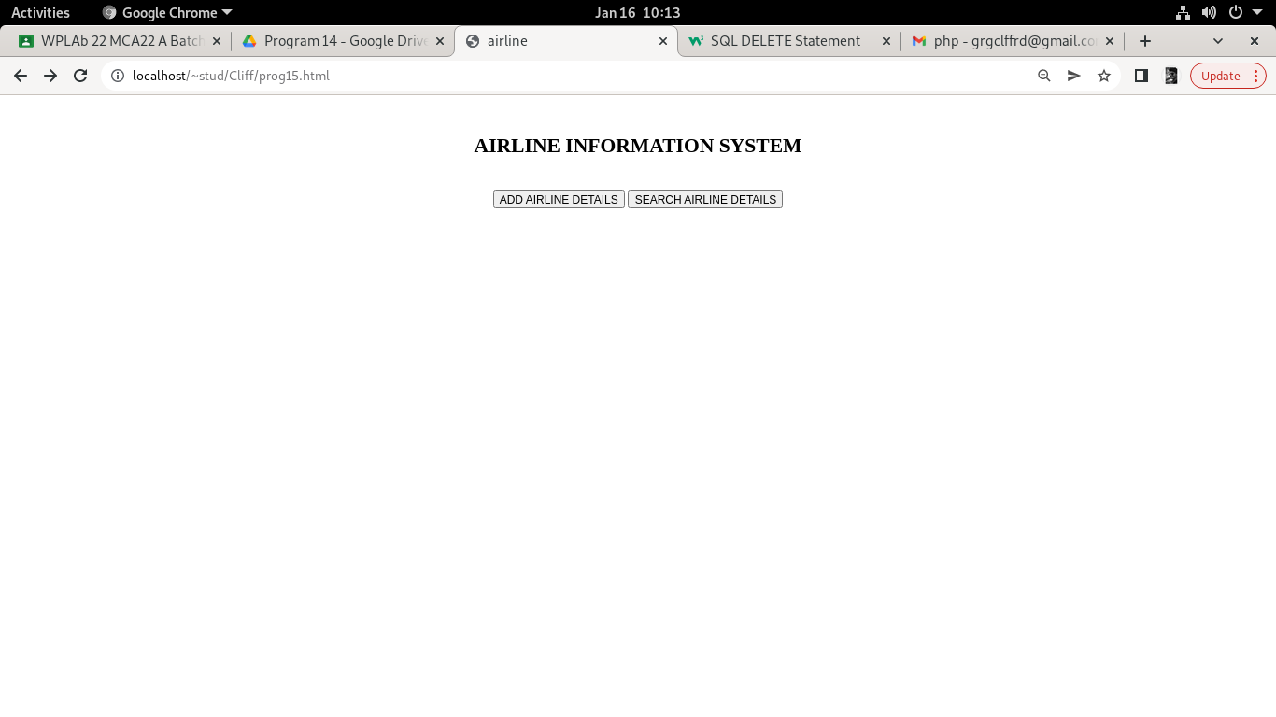

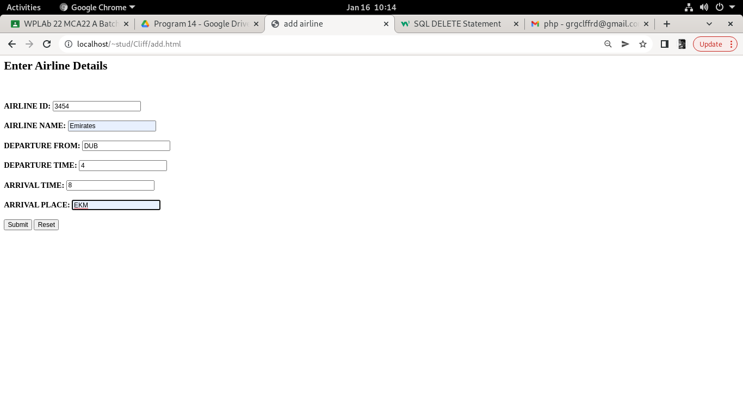

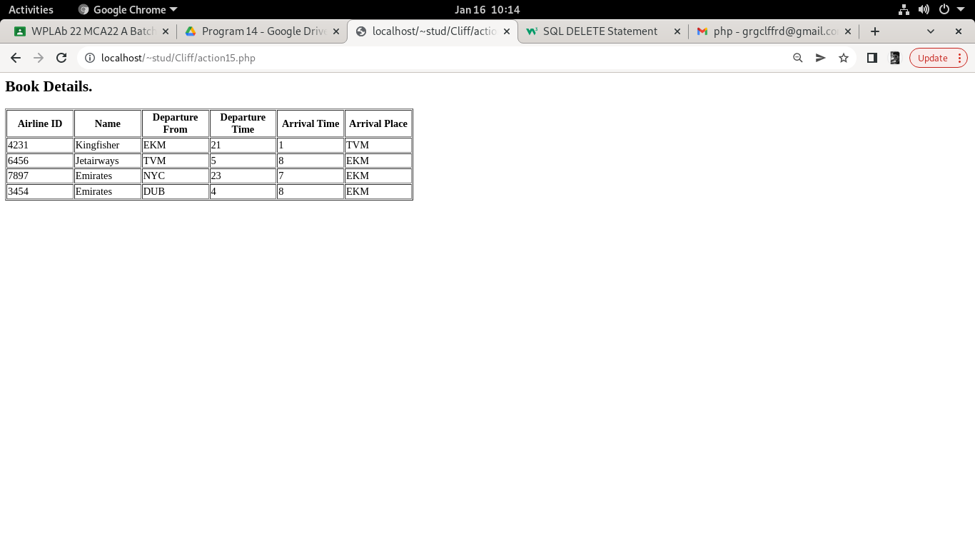

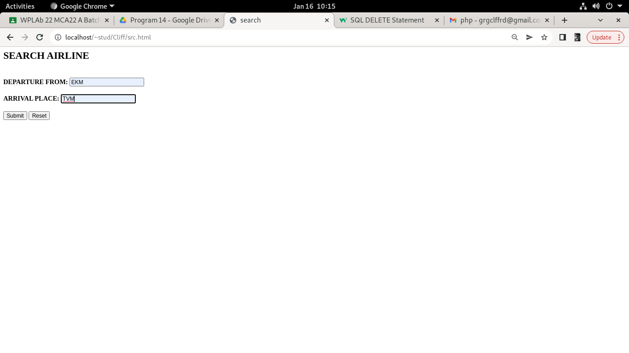

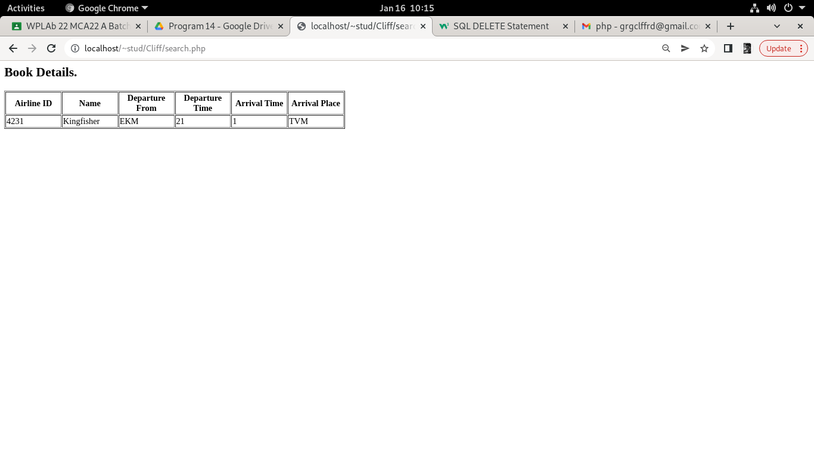

**Database**

